Inauguration of Kristu Jayanti EBSB Club
School of Management, Kristu Jayanti College, inaugurated Ek Bharat Shrestha Bharat (EBSB) club on 20th November 2019, 11am in the mini auditorium, 5th floor PG block of our campus. This initiative is to achieve the objective of Ek Bharat Shrestha Bharat. The aim of this club is to make the students of our institute to understand about EBSB and the paired state, Uttarakhand. The program was inaugurated by Rev. Fr. Emmanuel P J, Director Kristu Jayanti College of Law, Director Jayantian Extension Services and Jayantian Alumni Association, Kristu Jayanti College. The nodal officer, Dr Joseph Charles Tamilmaran and Dr. Sheeja Krishnakumar, Faculty, School of Management chaired the session.
The program started by giving a prelude to Ek Bharat Shrestha Bharat. In the prelude importance of mutual interaction & reciprocity between people of different states and developing a common spirit of understanding was narrated. A brief history and culture of Uttarakhand was also explained. The EBSB club was formally inaugurated by lighting the lamp Rev. Fr. Emmanuel P J. Rev. Fr. Emmanuel delivered the presidential address. In his address he explained the importance of establishing cultural exchanges between people of different regions for strengthening the feeling of unity towards nation-building. He also emphasised on the role of the students and the role of the higher education system in achieving the goals of EBSB. Fr. Emmanuel also encouraged the students to make Kristu Jayanti EBSB club the best in Karnataka, the best in South India and the best in the entire country.
The formal event was followed by a documentary and quiz on Uttarakhand. The narration of the documentary was done lively by first semester MBA students. The documentary film covered the culture, art forms, cuisines, geographical, political and historical importance of Uttarakhand. Four rounds of quiz were conducted on Uttarakhand state. There was a healthy competition and learning among the students. Students learnt about the objectives and the need of EBSB and also about the state of Uttarakhand. The program culminated with vote of thanks and National Anthem.
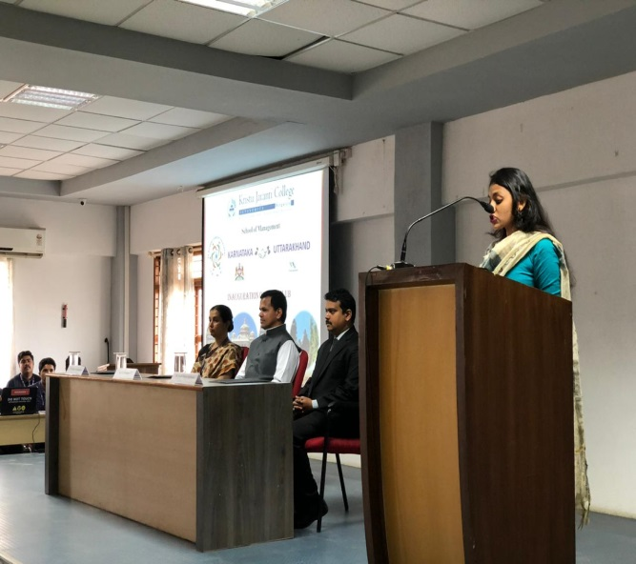 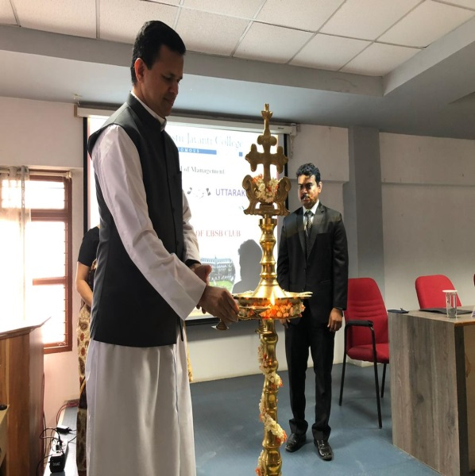 Inauguration function of EBSB Lighting the Lamp 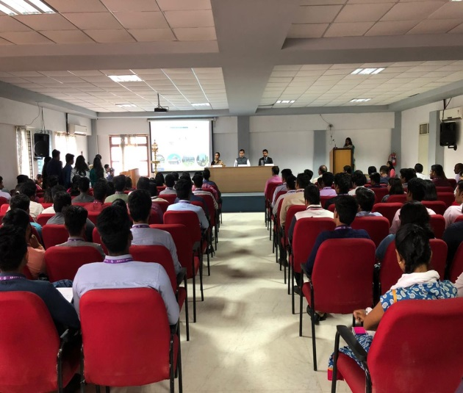 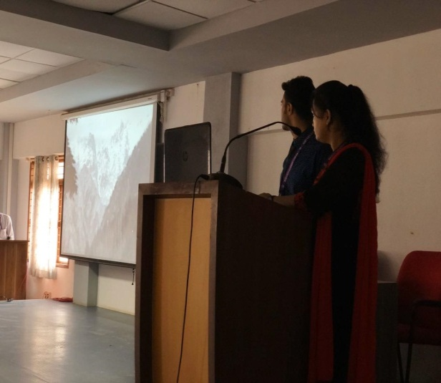
Quiz Documentary on Uttarakhand

Report prepared by

Dr. Joseph Charles Tamilmaran D,
Nodal Officer – EBSB,
School of Management,
Kristu Jayanti College
Bengaluru

